Activity 2 AppDev
SecureExam: Online Examination System
Subject: Application Development and Emerging Technologies
Name: Ruby Janne M. Batiancila BSIT 3B Date: 05/03/2026

Brief System Description:
The SecureExam Online Examination System is a web-based platform designed to make examination management more efficient, secure, and organized. It allows teachers to create exams, manage questions, publish access methods, monitor students during exams, communicate through chat, and grade submissions. Students can access exams through an access code or direct link, complete examinations online, communicate with teachers when needed, and view their results after submission.
The system improves traditional examination methods by reducing paperwork, minimizing manual errors, and providing faster access to results. It supports automated checking for objective-type questions, partial scoring, manual grading for subjective answers, and secure monitoring features such as camera monitoring, warning detection, and exam activity tracking.
SecureExam also includes role-based access for Admin, Teacher, and Student users. Each role has a dedicated dashboard and specific functions based on their responsibilities. The system also supports profile management, account theme customization, audit logs, admin reports, and visual charts for monitoring system activity. Overall, SecureExam provides a secure, user-friendly, and modern approach to online examination.
Actors / Users
- Admin – Manages users, views activity logs, monitors system data, oversees exams, and can access teacher and student-related functions.
- Teacher – Creates and manages exams, adds questions, selects access methods, monitors students, communicates through chat and voice messages, and grades submissions.
- Student – Accesses exams, checks in, takes exams, submits answers, communicates with the teacher, and views results.
Main System Functions
- User registration, login, and logout
- Role-based dashboards for Admin, Teacher, and Student
- Profile management
- Account theme customization
- User management by Admin
- Activity log monitoring
- Admin charts and reports
- Exam creation and management
- Add, edit, and delete exam questions
- Select access method: access code or direct link
- Publish and unpublish exams
- Student exam access through code or direct link
- Student check-in before exam
- Online exam taking and answer submission
- Automatic checking and scoring
- Partial scoring
- Manual grading by teacher
- View results and scores
- Real-time student monitoring
- Blocking, disable and Warning detection and during exams
- Teacher-student chat
- Voice message recording in chat
- Auto-ending exam when time expires
- Disable chat after exam completion

USE CASE DIAGRAM
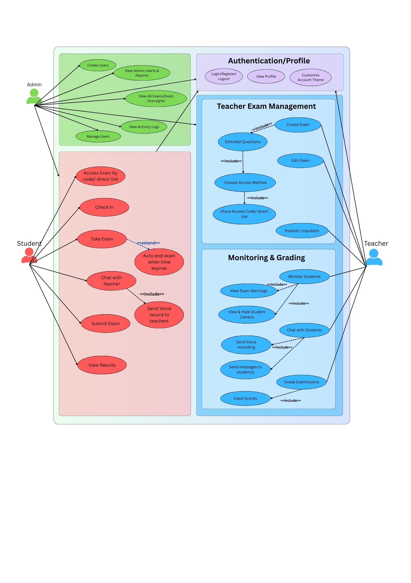

Use Case Diagram Description:
The UML Use Case Diagram illustrates how the Admin, Teacher, and Student interact with the SecureExam Online Examination System. It shows the major functions available to each user role and how these functions are connected. The Admin manages the overall system, the Teacher handles examination preparation and monitoring, and the Student completes the examination process.

The diagram also presents included and extended use cases to show dependent or optional system behaviors. These relationships help clarify how different features work together, such as exam creation, question management, access method selection, monitoring, chat communication, grading, and result viewing. Overall, the diagram provides a clear overview of the system’s scope, user responsibilities, and main functionalities.

